4.1 Create an unnamed pipe to communicate between parent process and child process. Accept a string (user input ) and the child process and pass the string to parent process to print and verify the contents.

Code:

#include<stdio.h>
#include<unistd.h>

int main()
{
char str[20];
char str1[20];
int fd[2];
printf("Enter the string: ");
fgets(str,20,stdin);
pipe(fd);
int f=fork();

if(f == 0)
{
puts(str);
write(fd[1],str,sizeof(str));
close(fd[0]);
}
else
{
read(fd[0],str1,sizeof(str1));
close(fd[1]);
puts(str1);
}
return 0;
}

Output:
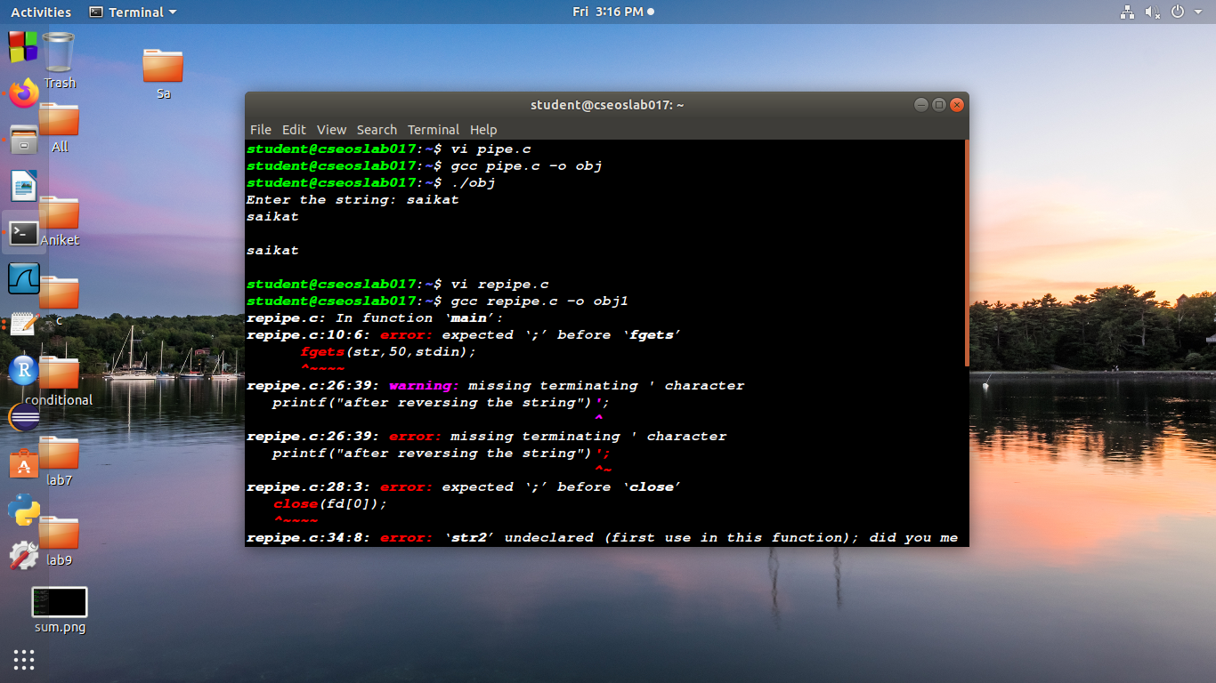
code:

#include<stdio.h>
#include<unistd.h>
#include<string.h>

int main()
{
int fd[2];
int temp;
char str[50];
char str1[50];
printf("Enter the string: ");
fgets(str,50,stdin);
pipe(fd);
int f=fork();

if (f<0)
{
printf("child process is not created");
}
else if(f == 0)
{
write(fd[1],str,sizeof(str));
sleep(10);
read(fd[0],str,sizeof(str));
printf("after reversing the string");
puts(str);
close(fd[0]);
}
else
{
printf("before reversing the string");
read(fd[0],str1,sizeof(str1));
puts(str1);
int len = strlen(str1);
for(int i = 0; i < len/2;i++)
{
temp = str1[i];
str1[i] = str1[len - i -1];
str1[len - i - 1] = temp;
}
write(fd[1],str1,sizeof(str1));
close(fd[1]);
}
return 0;
}

ouput:
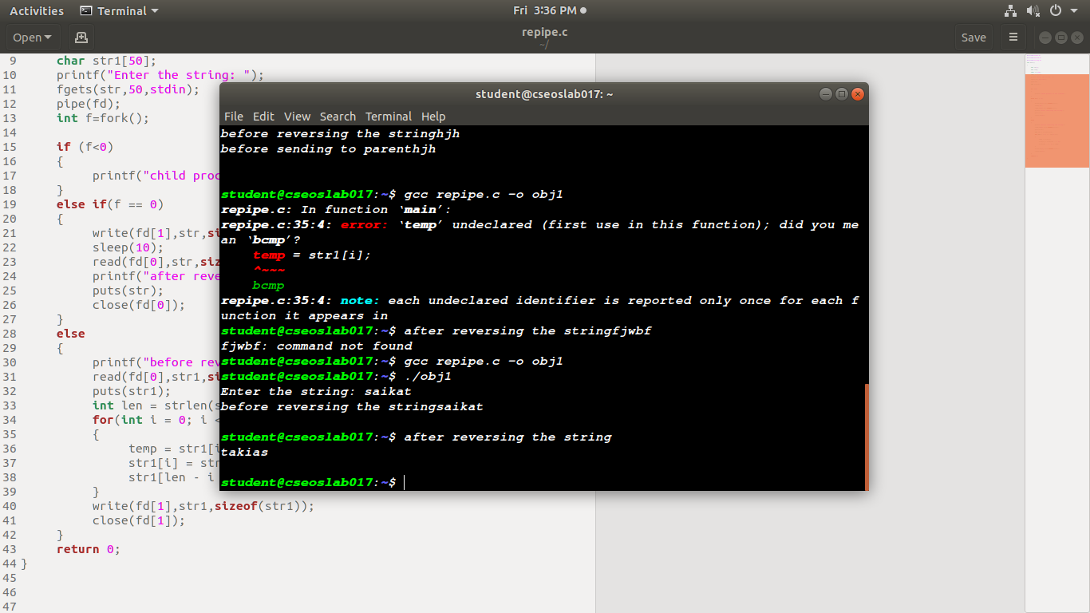
Create an unnamed pipe to communicate between parent process and child process. Use the pipe to send 2 integers x & y (user input) from child process to its parent process. Calculate x^y in parent process & send it to child process. Print the result in child process.

Code:

#include<stdio.h>
#include<unistd.h>

int main()
{
int fd[2];
int arr[2];
int arr2[2];
printf("Enter No :");
scanf("%d",&arr[0]);

printf("Enter power :");
scanf("%d",&arr[1]);

pipe(fd);

int f=fork();

if(f<0)
{
printf("no Child Process created");
}

else if(f==0)
{

write(fd[1],arr,sizeof(arr));

sleep(10);
read(fd[0],arr,sizeof(arr));
printf("Result is : %d",arr[0]);
close(fd[0]);
}
else
{
int res=1;
read(fd[0],arr2,sizeof(arr2));
for(int i=0;i<arr2[1];i++){

res= res*arr[0];
}
arr2[0]=res;
write(fd[1],arr2,sizeof(arr2));
close(fd[1]);
}
return 0;
}

output:
